**What is Overcoming Barriers up to lately? Resources for Professionals**

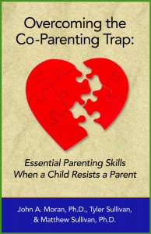

Overcoming Barriers has published our first **book** entitled

Overcoming the Co-Parenting Trap: Essential Parenting Skills When a Child Resists a Parent

Authored by Drs. John Moran, Matt Sullivan and Tyler Sullivan

It is available at Amazon.com

If you buy it and like it please give us a good review! All proceeds go to support the work of Overcoming Barriers.

**Coming in December 2015**

Plans are underway for an

**OVERCOMING BARRIERS’ Intensive Training for Professionals**.

For more information visit our website at [www.overcomingbarriers.org](http://www.overcomingbarriers.org)

Learn more about Intensives and our training at AFCC National in New Orleans.

Members of the OCB Board –

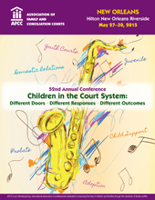

Drs. Robin Deutsch, Peggie Ward and Jack Moran

are presenting a pre-conference institute:

**Nuts and Bolts of An Intensive**

**Reunification Intervention When a**

**Child Resists a Parent**

Find our New Overcoming Barriers’ **Online Training** video at www.sfrankelgroup.com - CEUs are available

“**Legal Issues and Family Interventions When Children Resist Contact with a Parent**.”  Presented by Matthew J. Sullivan, Ph.D., Comm. Marjorie Slabach (ret.), and Rebecca Bailey, Ph.D.

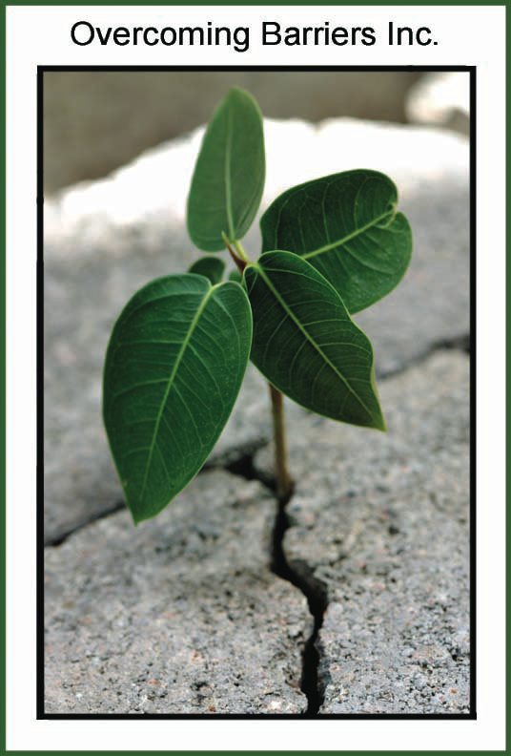

For More Info please visit us at www.overcomingbarriers.org