Attorney's BriefCase® Beyond the Basics™
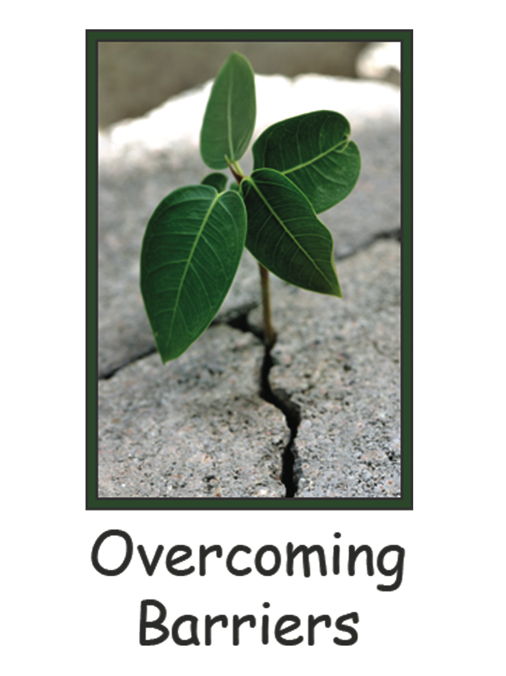

Presents

A Conversation with Overcoming Barriers

Legal Issues and Family Interventions
When Children Resist Contact with a Parent
An intensive 3-hour exploration of the complex and increasingly common dynamic of child resistance.

Presenters:
Michèle M. Bissada, JD
Sherrol L. Cassedy, JD, MA
Hon. Marjorie A. Slabach (Ret.)
Matthew J. Sullivan, Ph.D.

Live presentation (San Francisco) and Live Webcast
November 3, 2015, 6:00PM-9:20PM Pacific, 9:00PM-12:20 Eastern
Also available on DVD/CD

*Judges attendance (live or via webinar) is complimentary
Court personnel may attend for half price

Program approved by CA State Bar for 3.0 hours of Psychological Counseling Legal Specialization credit and MCLE credit by the California Board of Legal Specialization. Attorney’s Briefcase, Inc. certifies that this activity conforms to the standards for approved education activities prescribed by the rules and regulations of the State Bar of California governing minimum continuing legal education.

Attorney's BriefCase®
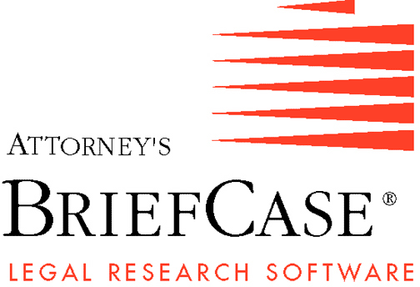
California Family Law
2915 McClure Street
Oakland, CA 94609
Tel. 510-836-2743/Fax 510-465-7348
e-mail: info@atybriefcase.com
Visit our Website at www.atybriefcase.com
Program Description:

This 3-hour seminar will explore the legal and mental health issues and interventions where children are resisting contact with a parent, an increasingly common dynamic in high-conflict families. The interdisciplinary panel will also explore the characteristics of high-conflict families, essential skills for parents on both sides of this dynamic, and the spectrum of legal and mental health resources and interventions for these families.

Special attention will be given to intensive psycho-educational programs such as Overcoming Barriers Family Camp and Intensives.

Seminar Leaders:

Michèle M. Bissada, JD: Ms. Bissada is a Certified Family Law Specialist and a Fellow of the American Academy of Matrimonial Lawyers. She is a partner at Flicker, Kerin, Kruger & Bissada, LLP, located in Menlo Park, in the heart of Silicon Valley. She received the Legal Aid Society’s 2010 Dorothy M. Wolfe Award for her pro bono efforts.

Sherrol L. Cassedy, JD, MA: Ms. Cassedy has had a law and mediation practice for 30 years working with hundreds of couples in complex personal and financial circumstances. Ms. Cassedy spent the first 20 years of practice as an advocate representing individuals in divorce and the past 10 years serving as neutral mediator and private judge. She is a Certified Family Law Specialist, Fellow of the American Academy of Matrimonial Lawyers, and has been recognized as an outstanding family lawyer.

Hon. Marjorie A. Slabach (Ret): Comm. Slabach presided over a Family Court in San Francisco Superior Court from 1997 to 2011. She has been a Certified Family Law Specialist since 1992. She has been honored as Judicial Officer of the Year by the State Bar F/L Section and AAML NorCal. She is the current President of Overcoming Barriers, Inc.

Matthew J. Sullivan, Ph.D.: Dr. Sullivan is in private practice in Palo Alto, California, specializing in forensic and clinical work in the Family Courts. His full-time practice focuses on work with high-conflict shared custody situations. He serves in a variety of court-related roles, including mediator, co-parent counselor, Parenting Coordinator, testifying expert and consultant. He received the 2012 Joseph Drown award for outstanding service to children by the AFCC, California chapter. Dr. Sullivan is a co-founder of Overcoming Barriers, Inc., which is a non-profit organization that has developed a variety of innovative programs for high-conflict shared custody arrangements.

$175 advance registration (*Judges attend free/Court Personnel half price)
$200 three days prior/Door
$200 DVD/CD (*Judges half price) *Email patty@atybriefcase.com/Call(510)836-2743

More Information at Overcomingbarriers.org
Location, Date and Time:

November 3, 2015 November 3, 2015
Tuesday Tuesday
San Francisco Live webcast
Parc 55 – A Hilton Hotel
55 Cyril Magnin. (Market at Fifth)
415-392-8000

6:00PM-9:20PM Pacific, 9:00PM-12:20 Eastern

Also available on either DVD or CD, which includes materials and program slides.

Space is limited

REGISTRATION FORM

____ November 3, 2015 San Francisco ____ November 3, 2015 Webcast
____ DVD/CD of presentation (circle choice)
and written materials

Name:
Firm:
Address:
City: State: Zip:
Phone: Fax: Email:
Credit Card (circle one): Visa MasterCard American Express Discover
Name on Credit Card:
Number: Expiration Date: Vcode:

Amount: ___$175 advance registration
___$200 three days prior/Door
___$200 DVD/CD (circle choice)
includes tax and shipping

$50 Cancellation Fee

To enroll, go online to www.atybriefcase.com; fax form to Attorney’s Briefcase, Inc. at (510) 465-7348; call (510) 836-2743, or mail completed form and check to
2915 McClure Street, Oakland, CA 94609

