Coparenting and the Parenting Coordination Process

Matthew J. Sullivan

ABSTRACT. Parenting coordination has an emerging role in child custody and access cases that provides a combination of legal and psychological interventions to address high conflict coparenting situa- tions. Despite the role’s rapid expansion, the literature has yet to explore the reasons why this role may be effective with the population of chronically litigating divorced parents. This article explores copar- enting after divorce from a structural family systems’ perspective and provides a conceptual framework for why the parenting coordination (PC) process is effective in assisting high conflict coparents to implement their parenting plans. The goal of disengaging high conflict coparents in order to create and maintain a parallel coparenting model is suggested as essential to the PC process. This article will describe various functions that can be uniquely provided in the PC process to disengage conflicted coparents, including: (1) working with coparents to enhance the detail and specificity of their parenting plan;

Matthew J. Sullivan, Ph.D., has been in private practice in Palo Alto, California since 1987. He has written articles, presented and conducted training at numerous national and international venues on topics such as high conflict divorce, parenting coordination and child alienation. He is cur- rently serving on the editorial board of the Journal of Child Custody and the Association of Family and Conciliation Courts Task Force on Parenting Coordination. He was recently appointed to an American Psychological Association and American Bar Association multi-year working group on legal and psychological interventions with children and families.
Address correspondence to Matthew J. Sullivan, 411 Kipling St., Palo Alto, California 94301. californiaparentingcoordinator.com. E-mail: sullydoc@aol.com.

Journal of Child Custody, Vol. 5(1/2) 2008 Available online at http://jcc.haworthpress.com
# 2008 by The Haworth Press. All rights reserved.
4 doi: 10.1080/15379410802070351

(2) using the parenting coordinator as the interface or functional link between the coparents, titrating the engagement of the coparents to facilitate adequate information exchange and effective decision- making about child-related issues while minimizing conflict; and (3) managing the involvement of the system external to the family.

KEYWORDS. Child custody, coparenting, high conflict divorce, parenting coordination, parenting plans

Parenting coordination has a rapidly expanding role in the family courts that is designed to assist high conflict parents in implementing their child custody parenting plan. It is a unique, legal=mental health hybrid role that provides intensive coparenting support by combining case management, education, dispute resolution, and coordination of communication for high conflict coparents (Coates et al., 2004; Sullivan, 2004; Kirkland & Kirkland, 2006). The Parenting Coordi- nator (PC) role emerged out of the repeated frustration and the fail- ure of the family court process to assist high conflict coparents through the divorce transition. These roughly 10–15% of divorcing parents (Johnston & Campbell, 1988) become stuck in the legal adversarial process, even after they obtain a judgment of their cus- tody disputes. In the early 1990s, judges and mental health profes- sionals who worked with divorcing coparents began a dialogue about these chronically litigating parents, who moved through the ‘‘conflict pyramid’’ (Maccoby & Mnookin, 1992), often necessitating custody evaluations and trials to establish their parenting plans, only to continue litigating the day-to-day issues that came up as they attempted to implement these custody orders. Judges, often dreading the appearances of these ‘‘frequent flyers’’ in the family court system turned to experienced mediators, custody evaluators, and family law specialists for a better process to serve these families.
This interdisciplinary dialogue spawned a new, hybrid legal= psychological role, the Parenting Coordinator (Coates et al., 2004), distinct in its elements from traditional roles in the family court – judge, mediator, custody evaluator, child’s attorney, Guardian ad litem (GAL), and therapeutic roles (child therapist, family therapist, coparent counselor, etc.). It contains many of the same aspects of these roles – neutrality, impartiality, formal court appointment, focus on dispute resolution and children’s best interests, is both evaluative

and educative – but provides a unique combination of legal authority, specialized knowledge and availability to high conflict families. The PC’s legal authority to make binding decisions can come from the delegation of judicial authority through a variety of means, including legal statutes, rules of court and orders of appointment (Kirkland, this volume). The PC’s specialized knowledge comes from training and experience in the areas of mediation, evaluation, experience working with the legal procedures of the family court, and family dynamics in high conflict coparenting situations (AFCC, 2003). Most importantly, the PC has the ability to work intimately and intensively with the comprehensive family system – parents, children, significant others, and the system that surrounds the family – extended family, educational, health and community contexts. The accessibility of the PC provides an essential element that, when combined with its authority and specialized knowledge, creates a role uniquely suited to manage these chronically conflicted families.
Not surprisingly, once the PC role became more established as infor- mation about its implementation in initial jurisdictions such as North- ern California and Colorado was disseminated, it burgeoned across jurisdictions in the United States and beyond (Coates et al., 2004). The PC role currently exists in many states, with eight states operating under specific statutes for PC work, while in several other states the role is performed using related statutes or rules of the state’s courts (e.g., Special Master and mediator). The rapid spread of the role speaks to both the need to provide more effective services to chronically high con- flict coparents and the promising benefits of the parenting coordination process. The process is ‘‘promising’’ at this point at best, because absent some initial studies of parenting coordination’s effectiveness in signifi- cantly reducing litigation post-appointment (Johnston, 1994; Vick & Backerman, 1996), there are no more empirical studies demonstrating if and how the role works. Kirkland and Sullivan (2008) provide a survey of interesting aspects of PC work, including findings that the role is multidisciplinary, but dominated by psychologists, performed by practitioners with an average of 18 years of experience and that it is a role with a high degree of professional risk.
The Asssociation and Family and Conciliation Courts (AFCC) Task Force on Parenting Coordination has contributed to the advancement of this emerging role in its two work products, address- ing implementation issues (AFCC, 2003) and providing a first set of model guidelines for the practice of Parenting Coordination (AFCC,

2006). The latter parenting coordination practice guidelines provide training recommendations thought to be essential to undertaking this challenging role. The implementation of the role – its defined authority, procedural determinants of the mediation-arbitration process – varies across jurisdictions, but the essential aspects of the role as an alternative dispute resolution and case management process for high conflict coparents are the common foci of the role. Several important questions have accompanied the emergence of the PC role. What makes it a more effective alternative to the tra- ditional court process to assist high conflict coparents implement their parenting plans? What are the characteristics of these high conflict coparents that lend themselves to the parenting coordination process? How does the parenting coordination process address the failure of these coparents to navigate through the ‘‘impasses’’ of their divorce? The answers to these questions are found in an understanding of the patterns of coparenting after divorce and the power of the parent-
ing coordination process to shape these coparenting patterns.

COPARENTING
The architects and guardians of healthy and adaptive family sys- tems are the parents, or as they are termed in family systems theory, the ‘‘executive subsystem’’ (Minuchin, 1974). Coparenting refers to the interactions of parents about their children and, therefore, does not include ‘‘the romantic, sexual, companionate, emotional, financial and legal aspects of the adults’ relationship that does not relate to childrearing’’ (Feinberg, 2003, p. 96). McHale et al. (2002) note that, ‘‘Effectively functioning coparenting units are those in which the significant adult figures collaborate to provide a family context that communicates to the child solidarity and support between parenting figures, a consistent and predictable set of rules and standards (regard- less of whether the unit is in one household or multiple) and a safe and secure home base’’ (p. 76).
Coparents must adjust to multiple transitions over the course of the family life cycle. These include the birth of each child, changes in work status, and predictable developmental stages of a child’s life (starting school, moving through adolescence, etc.). At each of these developmental transitions the failure of coparents to negotiate the transition in an adaptive manner can result in adjustment problems

for the child (McHale, 1997). The restructuring that is necessary must preserve the cooperation, communication and coordination between coparents that results in clear and agreed upon standards, and a demarcation of power with adults in charge.
No family structural reorganization is more challenging to coparents than the divorce transition. From this standpoint, divorce results in the reorganization of a nuclear family system to a binuclear family system. To be adaptive, parents need to establish functionality in their respect- ive residential situations during their custody periods and an efficient linkage between the residential subsystems. This linkage includes adequate child-focused information exchange and effective decision- making. When divorce occurs, there is a dissolution of the marital and financial partnership, and that process, combined with the psycho- logical impact of these losses, usually results in some degree of impair- ment to parenting and the functioning of the coparenting unit (Maccoby, Depner & Mnookin, 1990). For most coparents, this impair- ment is a transitional phenomenon and within 2–3 years adequately functional coparenting resumes (Ahrons & Rogers, 1987; Maccoby & Mnookin, 1992; Heatherington & Stanley-Hagen, 1995). For a small minority of divorcing parents, the high conflict becomes entrenched and impairs the cooperation, communication and coordination that is essential to healthy post-divorce child adjustment (Ahrons & Wallisch, 1987; Johnston & Campbell, 1988; Pruett et al., 2003).
Several studies of coparenting in the divorce context converge to provide findings that coparenting after divorce falls into four cate- gories of functioning (Ahrons & Rogers, 1987; Maccoby & Mnookin, 1992: Heatherington, 2003). These categories are created by two vari- ables–level of engagement and level of conflict. The engagement vari- able is defined by the degree of interaction that occurs between coparents and the conflict variable describes the quality of that inter- action. These variables are not discrete, nor do they create discrete categories of coparenting as illustrated in Table 1, but for the purpose of this discussion, these categories will be used.
As can be seen in Table 1, roughly 25% of coparents after divorce fall into the cooperative category. They have a High Level of Engage- ment and a Low Level of Conflict. Cooperative coparents are described as able to make agreements about their parenting plan, often on their own, or with minimal assistance from the educative and collaborative services the Family Court offers. They have accurate perceptions of themselves, their coparent and their children, operate

TABLE 1. Coparenting after Divorce

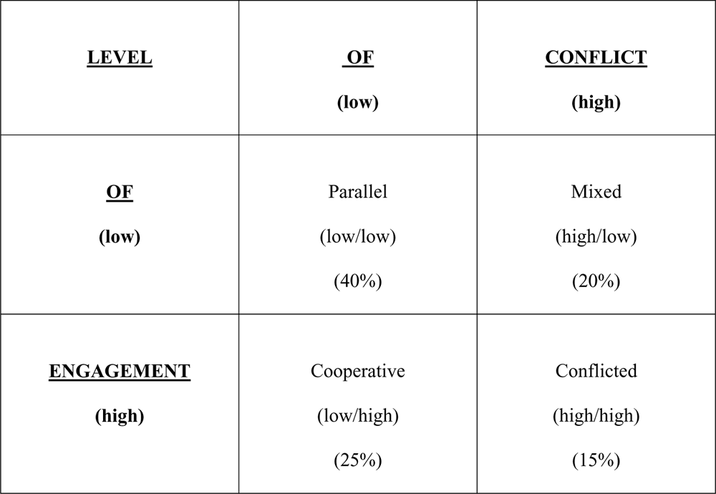

from a child-focus, are supportive of their coparent, and have an ability to communicate, problem solve and make joint decisions. They implement their parenting plan collaboratively and flexibly with their children’s best interests and sustaining a functional coparenting relation- ship as guiding principles. Not surprisingly, the children of cooperative coparents adjust quite well to the reorganization of their family from nuclear to binuclear (Heatherington & Stanley-Hagan, 1995; Kelly & Emery, 2003).
Conflicted coparents comprise 10–15% of those coparenting after divorce. They have a High Level of Engagement and a High Level of Conflict. Conflicted coparents have distorted perceptions of themselves, their coparents and their children. They tend to project their own needs onto their children, often couching them ‘‘In the name of the child’’ (Johnston & Roseby, 1997). They operate from an angry, often antag- onistic stance, communicate poorly, and their ability to problem solve and make joint decisions is quite impaired. Their breakdown in par- ental hierarchy and executive functioning lead to a neglect of their chil- dren’s needs and leave their children caught in the middle of their conflict. Conflicted coparents have little ability to use educative or col- laborative dispute resolution processes, and utilize the more adversarial family court processes (evaluation and litigation) to determine their parenting plan and often to repeatedly handle disputes in the implementation of their parenting plan. Perhaps the most robust

finding in the literature on children’s adjustment to divorce is that children of high conflict coparents suffer adjustment difficulties signifi- cantly more than children who live post-divorce in a cooperative copar- enting situation (Amato, 2000; Kelly & Emery, 2000; Kelly, 2007).
The third category is termed ‘‘mixed,’’ and comprises approxi- mately 10–20% coparents after divorce. These coparents engage in high levels of both supportive, cooperative coparenting and antagon- istic, conflicted coparenting, the so-called ‘‘angry associates’’ in Ahron’s sample (Ahrons & Rogers, 1987).
The most interesting category from the standpoint of the Parenting Coordination role is the parallel coparenting quadrant. The parallel parenting type is the most prevalent coparenting situation post- divorce, comprising at least 40% of coparenting types after divorce (Hetherington & Stanley-Hagan, 1995; Maccoby & Mnookin, 1992). These coparents have a low level of engagement and a low level of conflict. They have a low level of conflict, not because their interactions are cooperative, but because they minimize and avoid interactions. Their parenting plan may be agreed upon during the collaborative legal processes, or may be mandated or settled after considerable legal adversarial involvement. However, once the par- enting plan is established these coparents tend to adhere to the plan, parenting independently during their custodial time and having mini- mal or ‘‘disengaged’’ communication and joint decision-making about their child. Since conflict is dependent on interparental interac- tion, the level of engagement is the determining variable between conflicted and parallel parenting.
The parallel parenting model is intriguing for two reasons. First, because children who live post-divorce in this model appear to adjust post-divorce as well as children who are raised in a coopera- tive coparenting model (and, therefore, have better adjustment than children in higher conflict situations). Joan Kelly’s meta-analysis of children’s adjustment after divorce explains:

Cooperative coparenting promotes resiliency in children because of the parents’ ability to resolve differences on their own or with mediators or therapists as they arise. It has been reported that children whose parents engage in conflict-free parallel parenting also appear to thrive, as long as they have adequate parenting in both homes and well articulated parenting agreements and orders specifying contact and when joint decision-making is required will occur. (Kelly, 2007, p. 8)

Second, the engagement variable is amenable to interventions that move it along a continuum from high engagement to low engagement (disengagement). This is where the parent coordination process targets its interventions. The ability of the PC to ‘‘disengage’’ con- flicted coparents through the structure of detailed parenting plans and to become the functional linkage or interface between coparents is the essential effectiveness of the process. If successful, parenting coordination can move parents from the conflicted quadrant to the ‘‘conflict free’’ (or ‘‘conflict managed’’) parallel quadrant, which appears to be adequate for children’s reasonable adjustment post-div- orce (Hetherington & Stanley-Hagan, 1995). (See Table 2.)
This shift in focus among legal and mental health professionals who practice in the family courts, particularly for those who work with high conflict coparents, is essential. If family court interventions are intended to assist conflicted coparents to become cooperative (arrow A in Table 2), they keep the level of engagement high. This tends to keep the level of conflict high, as these parents can rarely resist the psychological and interpersonal pulls to engage in conflict. Interventions, such as parenting coordination, that work to disengage conflicted coparents with the goal of creating a parallel parenting model for these coparents (arrow B in Table 2) have a much greater likelihood of succeeding and having a positive impact on children’s adjustment in these families.
The remainder of this article will describe examples of interventions by PCs that disengage conflicted coparents, with the goal of stabilizing

TABLE 2. Focus of Intervention with High Conflict Coparents

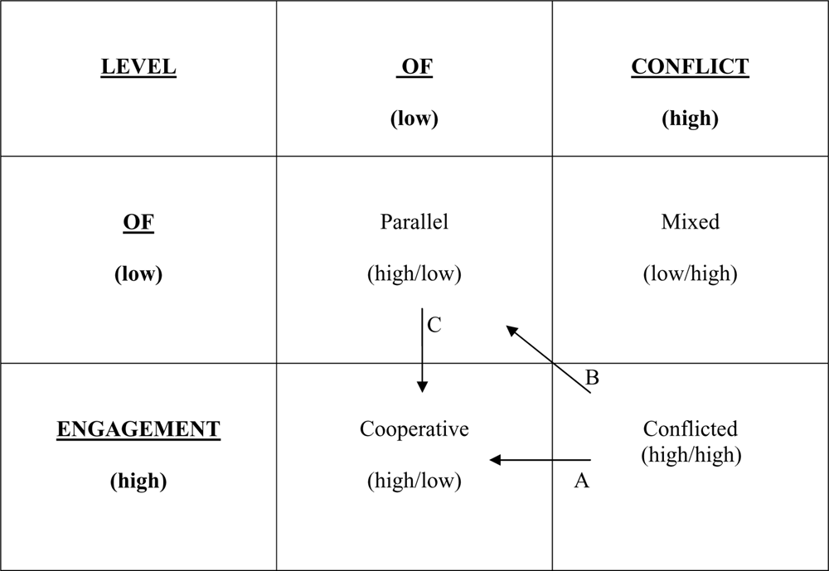

them in a parallel parenting model, and in some cases then work towards manageable cooperative engagement (arrow C in Table 2). Conflicted coparents rarely move directly to cooperative coparenting without experiencing some period of time (often years) in a parallel parenting model. This prolonged, functional disengagement can allow parents to deal with the intrapsychic, interpersonal and system-wide issues that maintain their high level of conflict (Jonhston & Campbell, 1988). During this period, the PC functions as the functional link between the coparents to assure adequate information exchange and decision-making in their childrearing relationship.

How the Parenting Coordination Process Disengages Conflicted Coparents
The process of disengagement has several components: (1) moving the parents out of their engagement in the legal adversarial context;
(2) establishing a new set of engagement rules in the parenting coor- dination context that support a parallel parenting model; (3) using the parenting plan to create structure to support parallel parenting;
- inserting the parenting coordination process as the functional linkage between the parents for adequate information exchange; and (5) using the PC as a readily available, effective decision- making=dispute-resolution resource.
Parents who engage in repeated litigation impair their ability to functionally coparent. The litigation process tends to exacerbate areas of disagreement and minimize cooperative communication for divorcing parents (Adamsons & Pasley, 2006). By virtue of their psychological vulnerabilities, dysfunctional patterns of interpersonal behavior and the trauma of the divorce transition, high conflict coparents often find themselves entrenched in the most adversarial processes in the Family Court. Repeated cycles of evaluation and liti- gation as a means of resolving custody (legal and physical=timeshare) and coparenting issues may interfere with parents’ ability to implement their parenting plan (information exchange, health, education, activities, discipline, etc.) as these adversarial processes train them to be effective litigants. The characteristics of litigants are antithetical to those of functional coparents (see Table 3).
Litigants, organized and fueled by the adversarial court process, tend to assume a personal advocacy position (or are represented by an advocate, their attorney). This advocacy stance often leads the parent not to take responsibility for their actions, and to approach

TABLE 3. Characteristics of Litigants and Coparents

Litigants Coparents

Representation–advocacy Self-representation – parenting
Distrust Trust
Sabotage of coparent Support of coparent
Win=lose Give and take
Chaos Structured flexibility
Avoidant and crisis-oriented Proactive and planful
Unilateral action Collaborative action
‘‘In the name of the child’’ Child-focus
Blame Problem-solving
Depleted resources Conservation of resources

problems and issues from a win=lose mentality. If they lose an issue, they tend to redouble their efforts (including sabotaging the efforts of their coparent to make them look bad) to prevail in the next round. Litigants’ trust of the other parent, perceived as an adversary, is nil, and since they have no confidence in the good intentions of their copar- ent, they tend to take unilateral childrearing action (which usually escalates the legal conflict). Their lack of negotiation skills, give and take or problem-solving mechanisms to resolve issues, lead to the depletion of emotional and financial resources that come from repeated exposure to dispute resolution processes in the legal-adversarial system.
Functional coparents work directly with each other in a collabora- tive manner, avoiding the legal-adversarial system and its multiple costs. They approach differences and issues with a child-focused, problem-solving approach, avoiding blame and engaging in a give and take process that builds trust and confidence in their coparent. They support the other’s parenting and are able to separate their par- enting relationship from the spousal relationship. They use their parenting plan to avoid disputes about timeshare schedules and parenting issues, but can be flexible about this structure as unexpec- ted issues arise. When they cannot manage these tasks, they seek coparenting assistance in its many available variations – mediation, coparent counseling, case management and, in its most intensive form, parenting coordination.

Establishing the Rules of the Coparenting Relationship
When a PC becomes involved in a case, the goal is to move liti- gation-oriented coparents into a context that can re-train them to

be functional coparents. There must be a clear demarcation when the parenting coordination process commences that announces to these parents that they are no longer working in a traditional legal adver- sarial process, and therefore the ‘‘rules of engagement’’ are different. The PC is immediately challenged by the litigation-oriented coparents entering the process, and must take charge and train parents to follow a new set of rules for their coparenting. These rules are organized by principles that support a parallel parenting model:

- A child has a right to a meaningful relationship with each parent.
- Each parent has a right to have a meaningful relationship with his or her child without the interference of the other parent.
- A child has a right not to be caught in the middle of parental
conflict.
- When parents separate, the most significant predictor of a child’s well-being is the level of conflict between the parents. Children exposed to high conflict have a poorer prognosis.
- If the parents do not get along, feel uncomfortable in each other’s presence, prefer not to deal with each other or, more seriously,
have an order of protection, then it is in the child’s best interest for parents to develop a parenting plan that eliminates the oppor- tunities for parental interaction resulting in conflict.
- Parents interact in a child-focused, businesslike and respectful manner.
- Nothing is assumed about the coparenting relationship; everything
is spelled out in the parenting plan.

Structural family systems theory tells us that relationship rules are established very early in relationships, in their initial interactions, and then reinforced by their repetition. Though largely unspoken and implicit, these rules are powerful organizers of relationship interac- tion. The parenting coordination process, by its clear, explicit rules, reflected in the detailed procedures in the order of appointment and=or service contract, sets down a structure that supports a parallel parenting model. The procedures mandate that communication fol- lows protocols for (1) how communication with the PC and the coparent can be initiated; (2) what the content should involve – only appropriate child-focused content; (3) how communication should be conducted – in a respectful, businesslike manner; (4) in what modality it will be communicated – in person, by phone, by email, by fax;

- the parameters of that communication mode – where, when and how communication occurs; and (6) how the results of that communication are documented (in what form, by whom, in what time period, etc.). These procedures detail and set the rules of engage- ment and they must be manageable to accomplish the business of coparenting.
Once appropriate rules of coparenting engagement (the structure) are defined in the PC process, by explicit, written policies, procedures and protocols, and by the provisions of the parenting plan, the PC’s challenge is to implement and maintain these rules (the process). Given the personality characteristics of high conflict coparents, articulately termed ‘‘narcissistically vulnerable’’ by Johnston and Campbell (1988), it should be assumed that parents in the parenting coordination process will challenge and violate these rules. The ongoing work of the PC as being in charge of the rules of engagement is to monitor and maintain these more functional coparenting rules. If they fail in this task, chaos and conflicted engagement will persist and the parenting coordination process will likely fail. The ‘‘training’’ involved in assisting these parents to accept and consistently follow the rules requires the PC’s patience, tolerance, persistence and skill, as their clients will employ a variety of strategies to undermine and violate the boundaries the PC sets.

The Parenting Plan as a Disengagement Tool
The initial task of the PC is to work on creating greater specificity in the parenting plan. This work will structurally disengage the copar- ents, reducing the ongoing business they need to transact to a mini- mal amount. Custody orders (parenting plans) that come from the court tend to be woefully inadequate for high conflict coparents to effectively implement. Essential areas or ‘‘gaps’’ are often not addressed or court orders leave ‘‘gray areas’’ where interpretation issues flourish and conflict breeds. The lack of detail in the parenting plan about the implementation of the regular schedule, holidays, transitions, protocols for required information exchange, right of first refusal, etc. can necessitate ongoing engagement that these high con- flict coparents cannot, nor should be expected to manage. The initial process of reviewing the parenting plan that comes with the PC appointment provides an essential, often collaborative educational and problem-solving exercise where the PC can guide the parents

through the existing plan, adding details that will eliminate the need for engagement, creating default clauses for issues that might avoid future dispute, detailing behavioral protocols for implementing orders (such as transitions, phone calls for the non-custodial parent, exchange of clothing, decision-making about child-related activities, etc.) and, ideally, providing written, up-front consequences for viola- tions of their parenting plan.
This task has numerous benefits for the initial parenting coordi- nation process. First, it provides specific guidance about the time- share schedule to allow coparents to create a calendar of custody for every minute of every day (which should be calendared at inter- vals to avoid disputes). It trains coparents to work proactively, with several months of custody scheduling, well prior to ‘‘crises’’ occurring due to poor planning and last minute issues arising. Ideally, the school year schedule should be completely calendared as soon as the school schedule is available, and the summer schedule (vacation periods, child activities, holidays, etc.) by mid-spring. Tightening up the schedule disengages the coparents and substantially reduces the potential areas of conflict.
Second, the task of working to improve the utility of the parenting plan usually generates successful agreements between coparents, cre- ating a model of collaborative problem-solving reflected in the modi- fied plan. This experience of success can motivate the parents to engage in the parenting coordination process, despite the despair, hostility and hopelessness reinforced from their previous failures. It enhances the credibility, confidence and trust in the parenting coordi- nation process as a viable alternative to the legal process, which helps build a working alliance with the parents.
Finally, this initial task creates a parenting plan that is a much better guide for implementation. It creates accountability for each coparent through specific behavioral expectations (through communi- cation and decision-making protocols) and provides consequences for violations of those expectations. Working with coparents on what the consequences should be for violations typically allows the PC to temper the parents’ inclination toward punitive outcomes, placing the PC in a more benign, compassionate authority position. Similarly, creating much more detailed and comprehensive coparent- ing provisions and having ‘‘up front’’ agreed upon consequences for violations of these parenting provisions places the PC in a more depersonalized authority position – not making nearly as many

decisions and ideally implementing agreed upon sanctions to support the parents’ directives rather than arbitrarily imposing these sanc- tions. The structural disengagement accomplished by the parenting plan works hand-in-hand with the PC’s ongoing role as the engage- ment interface between the coparents.

The PC as the Interface between Coparents
Once the PC has created more functional disengagement by adding additional structure to the parenting plan, the ongoing work with the coparents addresses the remainder of the coparenting business that needs to occur. This ongoing work can be broken down into three areas: (1) establishing and maintaining functional information exchange between the coparents; (2) decision-making=dispute resol- ution; and (3) case management. Like the work on the parenting plan, these aspects of PC work are geared to support a parallel coparenting model.

Establishing and Maintaining Functional Information Exchange Between the Coparents
Initial work on the parenting plan allows some assessment of the coparents’ ability to functionally engage, to interact in a businesslike, problem-solving and child-focused manner. If the parents cannot manage face-to-face interaction, the PC may intervene to titrate their engagement. What is crucial to understand is that in order to create a manageable level of engagement, the level of engagement needs to be manageable for the weaker link (the parent who cannot manage a higher level of engagement) in the coparenting dyad. The PC should not expect that the often more vulnerable (which can occur for many reasons) coparent will engage beyond his or her capacity, but rather structure their interaction so that the coparenting unit can interact adequately with a minimum of conflict.
Titration, that is, finding just optimum level of coparenting inter- action by the parenting coordination process, involves creating a manageable level of engagement to adequately exchange information and make decisions about child-related issues. The range of engage- ment (higher to lower) can be from face-to-face dialogue between parents (rare), to face-to-face dialogue in the PC’s office (often neces- sitating considerable structure – meeting agendas, protocols for inter- actions, etc. – and active intervention with the parents to avoid

escalation of conflict), to phone conferences (which eliminate non-verbal engagement), to email (which is not instantaneous, elim- inates verbal engagement, and since written, has accountability), to other less engaged written dialogue (fax and=or mail). Email communication is a particularly valuable modality as it is low on the engagement continuum, while having accountability and the ease of monitoring by the PC (by copying the PC on any emails between coparents). If a parent engages in problematic communi- cation by email, the PC can request that the parent email the PC first, so the PC can review, ‘‘edit,’’ and approve the communication prior to sending it to the other parent. This provides an additional level of disengagement and training in appropriate coparenting communication.
Some coparents require complete disengagement, with the PC act- ing as the total interface between them. In this model of coparenting, the PC works in a ‘‘shuttle diplomacy’’ model, working individually (in meetings, phone and written formats) with each parent to problem solve, reach agreements, or ultimately make decisions about issues within his=her scope of authority. This complete disengagement effec- tively sets up a process where each coparent only has to work with the PC (and the custody orders), not the other parent, which is often the only structure, at least initially, that can create a functional parallel parenting model. Operationally, this means that every communi- cation goes through the PC and the parents do not directly communi- cate except as directed by the PC.

Decision-Making=Dispute Resolution
In many jurisdictions a primary role of the PC is as an alternate dispute resolution process to the courts for parents when issues that arise in the implementation of their parenting plan (Kirkland, this volume). Even if the PC works diligently and comprehensively to provide further detail to close the gaps and gray areas where disputes occur, conflicts still arise, requiring a readily available effective means of resolving these implementation issues. Although the PC role requires well-developed mediation skills, the process more closely resembles a mediation-arbitration model of dealing with issues. Thus, the initial process that attempts to facilitate agreement between the parents about their dispute recognizes that the PC has the authority to make a recommendation or decision about the issue, should they

reach an impasse. The benefit of this context for settling disputes with high conflict coparents is that the PC’s views (coming from a con- sistent, child-focused, reasonable and collaborative stance) have considerable influence in the process, and this settlement-facilitation process can be quickly ended, if the PC determines that it will not be constructive. Unnecessarily prolonging and belaboring the meditative=facilitative phase of dispute resolution keeps the copar- ents in conflict, often escalating the anger, hostility and acting out that is so toxic to their relationship and their children. Speedy resol- ution to coparenting issues is one of the most beneficial aspects of the PC role for high conflict coparents.
Assuming the parents are unable to resolve their dispute collabora- tively, the PC is often authorized by the court to make a recommen- dation or binding decision about the issue. This arbitration process should be clearly spelled out in the appointment order, and tends to include more formal procedures to protect the rights of parents to have their input about the issues presented and considered. The PC’s role shifts to a ‘‘super-parent,’’ assuming the executive role as the parent in the family system, exercising sound parental judgment on behalf of the children. This decision-making process, if correctly performed, trains the parents in effective parenting and coparenting by modeling consistent, child-focused, fair resolutions to issues pre- sented. Whenever the PC can use issues presented as indicative of a need to add more rules and protocols to the parenting plan, they avoid the need to repeatedly address these issues each time they arise. For example, a parent may request to take the children to a wedding or funeral of a close family member, necessitating some switch of cus- todial time. Their coparent may unreasonably reject the request for this exchange. The PC should both resolve the immediate issue, by perhaps deciding that the parents will switch their custodial weekends to allow the children to attend the special family event, and also add a provision in the parenting plan that articulates what the protocol will be in the future if either parent makes such a request. The parenting plan provision will then include details of how the request should be made, the timing of response by the other parent, how compensatory time is handled, and how ‘‘special family event’’ is defined. For instance, what are the parameters of ‘‘family’’ and what are the criteria for ‘‘event’’ (wedding, funeral, special religious activity, etc.) that would qualify for inclusion in this provision? Helping parents to move from issue by issue dispute resolution to problem-solving classes of

issues is an important component of limiting their engagement with each other (and the PC eventually working him=herself out of a job). Documentation is a critical component of the decision-making process. Whether disputed issues are resolved by agreement of the par- ents or by PC decision, the process of memorializing these decisions supports the parallel parenting model. Written decisions (and proto- cols for handling future issues) should be specific enough to provide clear guidance to the coparents to implement. This avoids additional disputes arising out of different interpretations of the decision (a com- mon area of dispute with high conflict coparents), assists the PC in dealing with alleged violations and decreases the reliance on the par- enting coordination process. Documentation of agreements and deci- sions should be kept in the PC’s file (filed with the court, if mandated) and disseminated to everyone (with the exception of the child) who is impacted by the decision, with prior authorization. Besides the parents, this may include third parties, such as attorneys,
physicians, mental health professionals, school principals, etc.

Case Management
The PC’s coordination role in the case is a powerful tool in their disengagement arsenal. This PC function involves the management of the coparenting relationship, such as the structure of their engage- ment, the implementation the parenting plan, which may include modifications (as directed by the court) due to anticipated changes in the family situation and management of the professional and non-professional involvement of those in the community who sur- round the family. High conflict coparents are often overwhelmed by these coordination demands, and avoid dealing with childrearing issues, neglecting to provide essential support for their child and=or creating engagement with each other that escalates and maintains their conflict.
Parenting plans do not come with instructions and PCs can assist coparents with guidance and direction about how they should interact (with a level of engagement that is manageable and functional), when they should interact (daily, weekly, monthly, twice yearly), and with what procedures. The principles that should guide PCs in this case management function should include being proactive, predictable, planful, respectful and businesslike. A specific example of managing and structuring the business of coparenting is designing a protocol

to calendar the custody timeshare. When all the necessary information is available – the detailed provisions in the parenting plan that address the regular timeshare, holidays and vacations, the school calendar is issued and proposals for summer activities and vacations are ready to be presented – the PC should work with the parents to implement the protocol to manage their custody schedule on an ongoing basis. This timeshare management is successful after a calendar, based on the parenting plan, is finalized for the child(ren) that specifies, well in advance, where they will be every hour of every day for the school year and summer. These two periods are best addressed in the early fall (by mid-September) and early spring (by April), respectively. This timeshare management protocol trains the coparents to be proactive, dealing with schedules before they become issues or ‘‘crises,’’ and allows more flexibility to optimize the schedule because there are many opportunities to give and take across several months. Productive time- share management creates a forum to teach negotiation, and with the PC’s involvement, builds some trust in taking risks necessary for trust to build. As the process continues, these coparents learn to take on more responsibility for aspects of this protocol. They begin to work together on their own to agree to as much of the schedule as possible, only involving the PC for their disputed issues and start to share (alternating) the responsibility to document the schedule, by providing a calendar for review and approval by the other parent and PC. This type of ‘‘weaning’’ from more hands-on intensive interventions of the PC builds more independent coparent functioning by gradually replacing the involvement of the PC with coparent rules and structures created in the parenting coordination process.
These parents and children are surrounded by a system of extended family, professionals (legal, mental health, medical, educational, etc.) and non-professionals (friends, faith-based community, coaches, etc.) who should all be considered part of a ‘‘collaborative team’’ by the PC. These collaborative teams, even if comprised of competent community members, do not run themselves and are subject to being negatively impacted by the high conflict dynamics of the family sys- tem (Johnston & Roseby, 1988). The coordination of the individuals in this surrounding system is also a part of the PC’s case management function. Sullivan and Kelly (2001) more specifically address how the PC role is uniquely suited to manage the involvement of these teams in high conflict coparenting cases. These authors provide general principles of collaborative team functioning that include what to

consider when building a collaborative team of professionals and non-professionals, and how to manage aspects of team functioning such as communication (including the issue of confidentiality), hierarchy, team roles and monitoring team goals and objectives. Successful management of those in the community significantly involved with the family ideally creates and maintains a child- focused, collaborative system necessary to address the polarities and conflict that typically exist in the family system.

CONCLUSION
The efforts of the PC that promote or maintain higher levels of engagement may do more harm than good in high conflict child cus- tody cases. Instead the goals of parenting coordination work should be to structurally disengage high conflict coparents using the multiple functions unique to the PC role – increasing the specificity of the par- enting plan, operating as the interface for the communication between coparents to titrate their interaction so that they can man- ageably conduct the business of coparenting – optimizing child- focused information exchange and decision-making – and providing case management that organizes coparents to operate in a parallel coparenting manner and those involved in their surrounding context to operate in a collaborative manner. If these goals can be attained in the parenting coordination process, there is some support in the literature that coparents and their children may be well served by parenting coordination.
Questions remain, however, about whether the parenting coor- dination process is effective at disengaging all high conflict copar- ents. Without appropriate structure and boundaries in the parenting coordination process, one of its beneficial aspects, its easy accessibility, can become a forum to maintain a high level of engagement and conflict. This is a particular concern when issues of inequities in power and control typical in violent families exist. Also, even when effective in disengaging coparents, if the process does not encapsulate the toxic aspects of conflict on chil- dren – loyalty tensions, denigration of the image of the other par- ent, alienation, etc. – those factors may still negatively impact children’s adjustment even when a PC is accomplishing the goals addressed in this article. Finally, the current article does not

address ‘‘parenting’’ issues that are relevant to children’s adjust- ment and, therefore, to PC interventions – how to deal with problem parenting and how it impacts the coparenting dyamics and children’s adjustment in high conflict situations. Clearly, par- enting and coparenting are not independent variables impacting children and the relationship of these functions is likely complex and poorly understood. Research focused on these questions could enhance our understanding of the utility of and provide guidance to the development of the PC role. The expansion of research on parenting coordination work will hopefully support its burgeoning use and build a body of outcome data to support the legitimacy of this role as a useful part of the spectrum of interventions available to high conflict post-divorce families.

REFERENCES
Adamsons, K., & Pasley, K. (2006). Coparenting after divorce and relationship dis- solution. In M.A. Fine & J.H. Harvey (Eds.) Handbook of divorce and relationship dissolution (pp. 241–263). New Jersey: Lawrence Erlbaum Associates.
Ahrons, C., & Rogers, R.H. (1987). Divorced families: A multidisciplinary develop- mental view. Markham, Ontario: Penguin.
Ahrons, C., & Wallisch, L. (1987). The relationship between former spouses. In
D. Perlman & S.S. Duck (Eds.) Intimate relationships: Development, dynamics and deterioration (pp. 269–296). Newbury Park, CA: Sage.
Amato, P. (2000). The consequences of divorce for adults and children. Journal of Marriage and the Family, 62, 1269–1288.
Association of Family and Conciliation Courts Task Force on Parent Coordination (AFCC) (2003). Parent coordination: Implementation issues. Family Court Review, 41(4), 533–564.
Association of Family and Conciliation Courts Task Force on Parenting Coordi- nation (AFCC) (2006). Guidelines for parenting coordinators. Family Court Review, 44(1), 164–181.
Coates, C.A., Deutsch, R., Starnes, H., Sullivan, M.J., & Sydlik, B. (2004). Parenting coordination for high-conflict families. Family Court Review, 42, 246–262.
Feinberg, M.E. (2003). The internal structure and ecological context of coparenting: A framework for research and intervention. Parenting: Science and Practice, 3, 95–131.
Heatherington, E.M. (2003). Intimate pathways: changing patterns in close personal relationships over time. Family Relations, 52, 318–331.
Heatherington, E.M., & Stanley-Hagen, M.M. (1995). Parenting in divorced and remarried families. In M.H. Bornstein (Ed.) Handbook of Parenting (Vol. 3, pp. 233–254). Hillsdale, NJ: Lawrence Erlbaum Associates.

Johnston, T. (1994). Summary of research on the decrease of court involvement after the appointment of a special master. Unpublished report.
Johnston, J.R., & Campbell, L. (1988). Impasses of divorce: the dynamics and resol- ution of family conflict. New York: Free Press.
Johnston, J.R., & Roseby, V. (1997). In the name of the child: A developmental approach to understanding and helping children of conflicted and violent divorce. New York: Free Press.
Kelly, J.B. (2000). Children’s adjustment in conflicted marriage and divorce: A decade of research. Journal of the American Academy of Child and Adolescent Psychiatry, 39, 963–973.
Kelly, J.B. (2007). Children’s living arrangements follow separation and divorce: Insights from empirical and clinical research. Family Process, 46, 35–52.
Kelly, J.B., & Emery, R. (2003). Children’s adjustment following divorce: Risk and resiliency perspectives. Family Relations, 52, 352–362.
Kirkland, K., & Kirkland, K.E., (2006). Risk management and aspirational ethics for parenting coordinators. Journal of Child Custody, 3(2), 23–43.
Kirkland, K., & Sullivan, M., (2008). Parenting coordination practice: A survey of experienced professionals. Family Court Review, in press.
Maccoby, E.E., Depner, C.E., & Mnookin, R.H. (1990). Coparenting in the second year after divorce. Journal of Marriage and the Family, 52, 141–155.
Maccoby, E.E., & Mnookin, R.H. (1992). Dividing the child: Social and legal dilem- mas in custody. Cambridge, MA: Harvard University Press.
McHale, J.P. (1997). Overt and covert coparenting processes in the family. Family Process, 36, 183–201.
McHale, J.P., Khazan, I., Erera, P., Rotman, T., DeCourcey, W., & McConnell, M. (2002). Coparenting in diverse family systems. In M. Bornstein (Ed.) Handbook of parenting (pp. 75–107) (2nd Ed.). New Jersey: Erlbaum.
Minuchin, S. (1974). Families and family therapy. Cambridge, MA: Harvard University Press.
Pruett, M.K., Williams, T.Y., Insabella, G., & Little, T.D. (2003). Family and legal indicators of child adjustment among families with young children. Journal of Family Psychology, 17(2), 169–180.
Sullivan, M.J. (2004). Ethical, legal and professional practice issues involved in acting as a parenting coordinator in child custody cases. Family Court Review, 42(3), 576–582.
Sullivan, M.J., & Kelly, J.B. (2001). Legal and psychological case management with an alienated child. Family Court Review, 39, 299–315.
Vick, M., & Backerman, R. (1996). Mediation arbitration: Surveys of professionals and clients. Paper presented at the Boulder Interdisciplinary Committee on Child Custody, Boulder, CO.

SUBMITTED: June 14, 2007
REVISED: January 5, 2008
ACCEPTED: March 1, 2008

